İKİLİ FİLTRE DIŞ KABI

APPLICATIONS
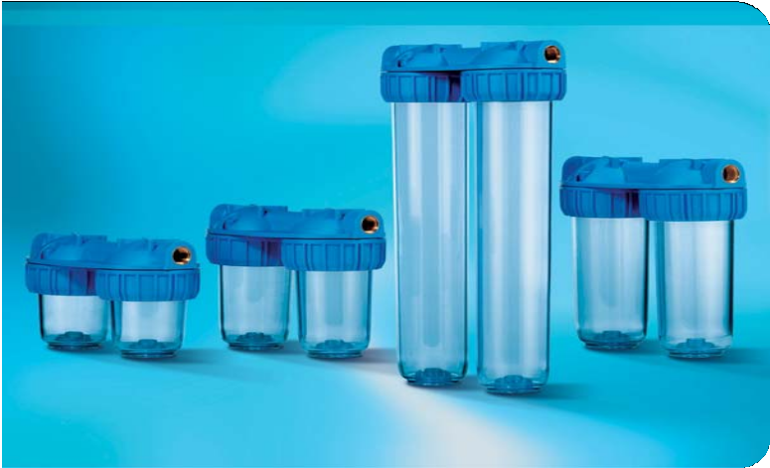Filtration and treatment of water with neutral pH and drinking water. The exclusive Duplex housings allow faster and safer installation of serial filtration units.
Medium
Junior
Master
Senior
Domestic use: filtration and treatment of drinking water, protection of taps, boilers, washing machines, and other installations.
Technical use: pre-filtration, micro-filtration; protection of pumps, heating systems, softeners, demineralising and chlorine-removing appliances, reverse osmosis units.

WORKING CONDITIONS
Max working pressure 8 BAR Max working temperature 45°C

SPECIFICATIONS
Non-toxic materials, suitable for drinking water. Head and ring nut: reinforced polypropylene. Transparent bowl: SAN.
O-ring: ETP.
Breather-valve: body polypropylene, O-ring ETP.
IN/OUT threads: CW 614 N brass inserts.
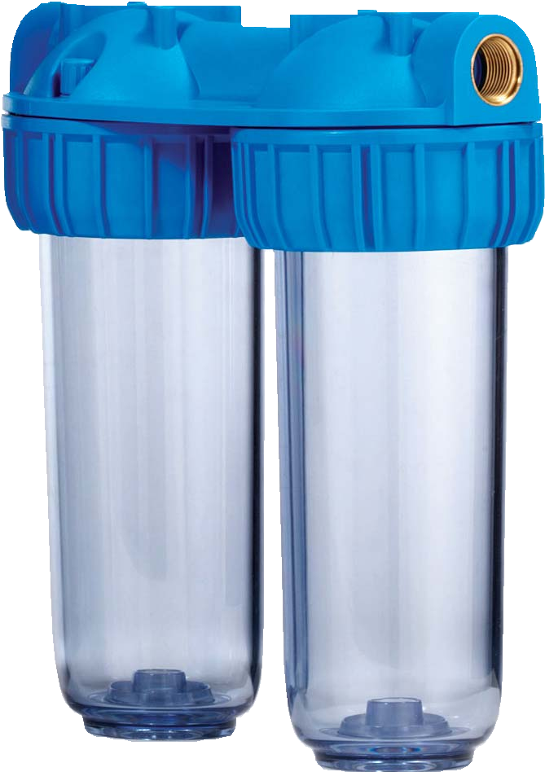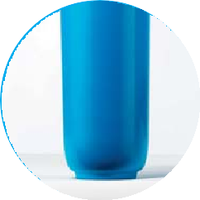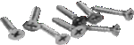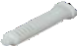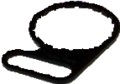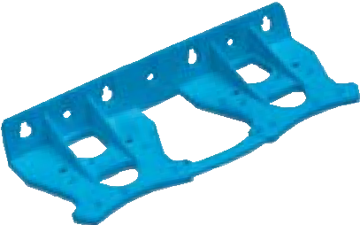
B
A
VARIANTS available on minimum quantity

FP female plastic IN/OUT AB housings with opaque threads, BSP type 3/4”. bowl, impermeable to the
light.
accessories
Cartridge height | housings with transparent bowl AS IN/OUT female threads with FO brass inserts | IN/OUT  threads | mm
 |  |  | A | B
10” | Senior Duplex Plus 3P AFO SX AS | 3/4” | 315 | 275

